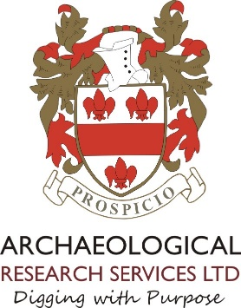
Person Specification

Project Officer

 | ESSENTIAL | DESIRABLE
EDUCATIONAL AND OCCUPATIONAL ATTAINMENTS | Educated to 2:1 degree level or above  Membership of Chartered Institute for Archaeologists | A relevant professional qualification (e.g. Member of CIfA) or post-graduate qualification (e.g. PhD, Masters)
EXPERIENCE | Experience of working in an office environment and conducting oneself in a highly professional manner.  Experience of running archaeological projects, running sites, supervising and motivating staff and dealing with clients, curators and the public  Documented experience of organising and delivering post-excavation work and producing high quality written work, digital graphics and reports.  Experienced in exercising sound judgement and delivering successful outcomes that take account of the subtleties and complexities of archaeological data.  Experience of report checking, including evaluation, excavation and other types of reports  Experience of successfully working to deadlines, working under own initiative as well as in part of a team.
SPECIAL SKILLS | Full archaeological fieldwork skills, including ability to survey and layout trenches.  Authentic high quality communication skills (listening, oral and written) and ability to quickly build rapport with teams and line manager.  Excellent written English and ability to express oneself accurately and take account of the nuances required in the production of first rate reports.  Self-discipline, attention to detail, excellent numeracy, forensic accuracy.  Excellent organisational skills.  Excellent team management and leadership skills.  Ability to prioritise many concurrent tasks based on daily, weekly, monthly and annual goals.  Highly computer literate including use of Microsoft Office, CAD or commitment to learning it quickly, survey software.  Full driving license. | Speaking in meetings, and giving talks and presentations etc.  Writing full and persuasive project designs.
DISPOSITION | Trustworthy and have integrity.  Exceptionally organised.  Humble but confident.  Willing to function and contribute as part of a motivated and thriving team and willing to take instructions.  Very resourceful and natural problem solver.  Outstanding interpersonal skills.  A real team player.  Motivated to help others.  Loyal.  Able to remain calm, confident and competent under pressure.  Desire to be the best you can be.  Good sense of humour. | Cheerful.
INTERESTS | Archaeology of Britain. | Period or thematic specialisms.
SPECIAL REQUIREMENTS | Willing to work a range of hours in order to attend meetings, take advantage of training courses, and ensure quotations and tenders are completed before deadline.  Able and willing to travel throughout the UK for site visits, meetings, conferences, training etc. including outside of work hours  Ambitious to assist in growing the company, assisting with staff development and taking it forward.  Keen to align oneself with, and promote, the vision, mission and values of the company.

