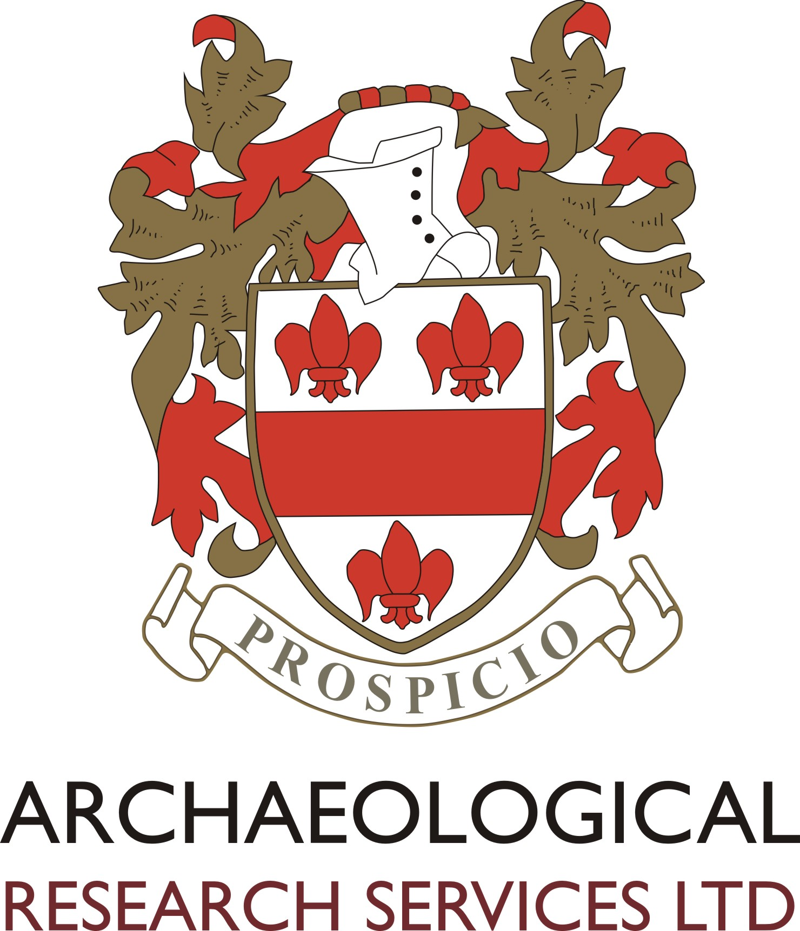

PERSON SPECIFICATION

POST TITLE: Archaeological Officer

 | ESSENTIAL | DESIRABLE
EDUCATIONAL AND OCCUPATIONAL ATTAINMENTS | Educated to 2:1 degree level or above | A relevant post-graduate or other professional qualification  Membership of the Chartered Institute for Archaeologists
EXPERIENCE | Experience of working in a professional environment  Experience of taking part in archaeological projects, undertaking a range of fieldwork and post-excavation tasks and dealing with a wide-range of people
SPECIAL SKILLS | Excellent organisational skills  Good range of IT skills including familiarity with CAD and GIS  Full archaeological fieldwork skills  Self-discipline, attention to detail, excellent numeracy, forensic accuracy.  Excellent organisational skills.  Full driving license | CSCS Card  Surveying skills
DISPOSITION | Trustworthy and have integrity.  Exceptionally organised.  Humble but confident.  Willing to function and contribute as part of a motivated and thriving team and willing to take instructions.  Very resourceful and natural problem solver.  Outstanding interpersonal skills.  A real team player.  Motivated to help others.  Loyal.  Able to remain calm, confident and competent under pressure.  Desire to be the best you can be.  Good sense of humour.
INTERESTS | Archaeology of Britain | Period or thematic specialisms
SPECIAL REQUIREMENTS | Willing to work a range of hours (inc. occasional weekend work) in order to take advantage of training courses, attend meetings, and carry out project work etc.  Able and willing to travel throughout the UK and work away for jobs, training etc. including outside of work hours.  Ambitious to assist in growing the company, and take part in professional and personal development.  Keen to align oneself with, and promote, the vision, mission and values of the company.

